Chapter 9 – Nervous System

1. What are the different neurotransmitters released in the neuromuscular junction pertaining to the Nervous System? What are their functions? Which are the natural pain killers?
2. What is the definition of interneuron? Where are they found? What do they connect?
3. What are the functions of microglia?
4. What is the myelin sheath? What is it made of? What is its function?]
5. What is saltatory conduction? What is its purpose?
6. What is the definition of a nerve impulse? A nerve?
7. What is a synapse? What are the parts of a synapse? What do the postsynaptic and presynaptic neurons do?
8. Define the following:
   1. Astrocytes:
   2. Microglia:
   3. Schwann cells:
   4. Oligodendrocytes:
9. Postganglionic neurons release acetylcholine as part of which nervous system?
10. How many neurons make up a reflex?
11. Label the following: Where are muscle coordination, conscious thought, auditory, and visual functions found? 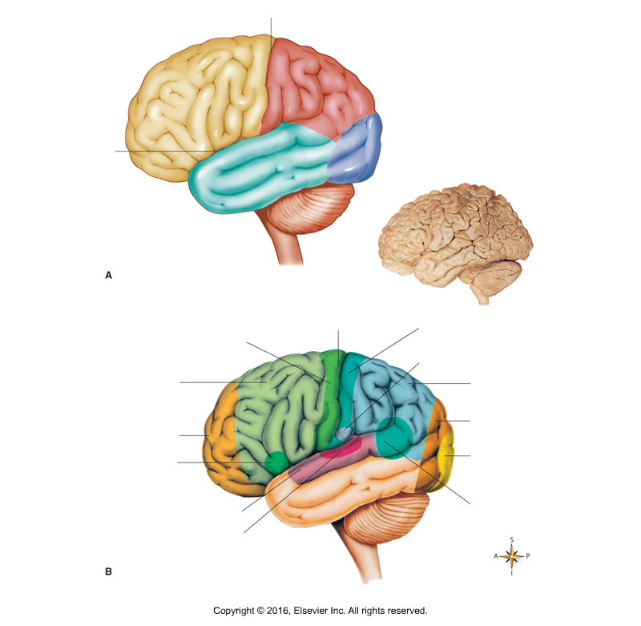
12. What is the difference between the parasympathetic and sympathetic system?
13. Draw a neuron with all of the different parts including axon, dendrites, cell body, node of Ranvier, myelin sheath, and show the direction that impulses travel on the neuron.
14. What do the thalamus, medulla oblongata, cerebellum, and hypothalamus regulate?
15. The right and left sides of the cerebrum are connected by the ______________ __________________.
16. Fill in this diagram of the divisions of the nervous system:



1. Compare and contrast motor neurons and sensory neurons.
2. What are glia cells? What is their function?
3. Describe specific characteristics of the cerebellum?
4. What structures are part of the diencephalon?